Task 2: Data Retrieval & Sorting Dashboard
Description: Create a page that displays student or employee records with:
Sorting by name or date
Filtering by department Count of students per department
Aim:
To develop a data retrieval dashboard that displays student records with sorting, filtering by department, and department-wise count using SQL queries.
Algorithm:
- Connect to the MySQL database
- Retrieve student records using SELECT query
- Apply filtering using WHERE clause based on department
- Apply sorting using ORDER BY (name or date of birth)
- Display the records in tabular format
- Use GROUP BY to count students in each department
- Display the count results
Program:
import React, { useState } from "react";

const initialData = [
{ id: 1, name: "Aisha", department: "Computer Science", date: "2024-01-12" },
{ id: 2, name: "Rohan", department: "Mechanical", date: "2023-11-22" },
{ id: 3, name: "Meena", department: "Electrical", date: "2024-02-05" },
{ id: 4, name: "Vikram", department: "Civil", date: "2023-12-18" },
{ id: 5, name: "Kavya", department: "Computer Science", date: "2024-03-10" },
{ id: 6, name: "Arjun", department: "Mechanical", date: "2024-01-30" },
];

export default function Dashboard() {
const [data, setData] = useState(initialData);
const [filterDept, setFilterDept] = useState("All");

const handleSort = (key) => {
const sorted = [...data].sort((a, b) => {
if (key === "name") return a.name.localeCompare(b.name);
if (key === "date") return new Date(a.date) - new Date(b.date);
return 0;
});
setData(sorted);
};

const filteredData =
filterDept === "All"
? data
: data.filter((item) => item.department === filterDept);

const departments = [
"All",
...new Set(initialData.map((item) => item.department)),
];

const deptCounts = initialData.reduce((acc, item) => {
acc[item.department] = (acc[item.department] || 0) + 1;
return acc;
}, {});

return (
<div className="p-6 max-w-4xl mx-auto">
<h1 className="text-2xl font-bold mb-4">Student Dashboard</h1>

<div className="flex gap-4 mb-4">
<button
onClick={() => handleSort("name")}
className="px-4 py-2 bg-blue-500 text-white rounded"
>
Sort by Name
</button>

<button
onClick={() => handleSort("date")}
className="px-4 py-2 bg-green-500 text-white rounded"
>
Sort by Date
</button>

<select
value={filterDept}
onChange={(e) => setFilterDept(e.target.value)}
className="px-4 py-2 border rounded"
>
{departments.map((dept) => (
<option key={dept} value={dept}>
{dept}
</option>
))}
</select>
</div>

<table className="w-full border">
<thead>
<tr className="bg-gray-200">
<th className="p-2 border">Name</th>
<th className="p-2 border">Department</th>
<th className="p-2 border">Joining Date</th>
</tr>
</thead>
<tbody>
{filteredData.map((item) => (
<tr key={item.id}>
<td className="p-2 border">{item.name}</td>
<td className="p-2 border">{item.department}</td>
<td className="p-2 border">{item.date}</td>
</tr>
))}
</tbody>
</table>

<div className="mt-6">
<h2 className="text-xl font-semibold">Department Counts</h2>
<ul className="list-disc ml-6">
{Object.entries(deptCounts).map(([dept, count]) => (
<li key={dept}>
{dept}: {count}
</li>
))}
</ul>
</div>
</div>
);
}
Output:
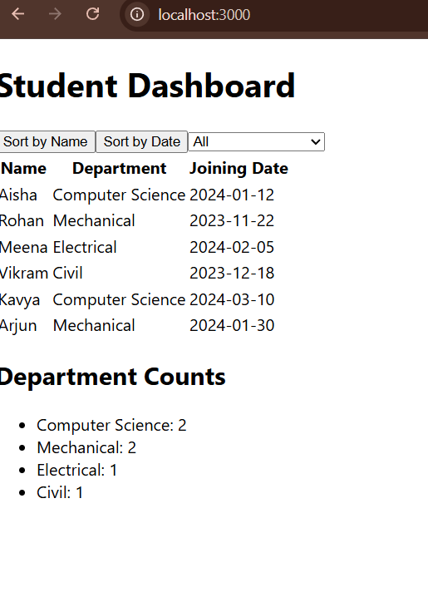

Result:
The dashboard successfully displays student records with sorting and filtering options.
It also shows the count of students in each department using SQL aggregation.

